Personal Traineeship Report

- Experience of being abroad (all by yourself…)

This internship enabled me to discover a beautiful country : Switzerland! By coming here alone, I could be very curious and discover new people. During the IAESTE weekends everyone was meting each other for the first time and that was awesome.

- Experience at work

I had an interesting mission for my internship, and have been really welcomed in my company. I indeed discovered a different way of working here in Switzerland compared to my home country (France). Everyone is responsible for his work, you have to work for the time allotted but you can organize yourself as you want. Trust and autonomy are well present in the company! All of my colleagues have been really nice to me, not many of them could speak English but they always showed great patient towards me even though my German wasn’t very good.

- Cultural differences / shock

Swiss german was really hard to understand! But apart from this everything went very well. I will miss the beautiful mountain landscape and the numerous lakes!

- IAESTE

IAESTE was the best way to discover very nice people from all over the World! The IAESTE weekends were definitely the best experiences of my stay here. I had great time with many other IAESTE interns in Zürich and Bern. IAESTE also helped me a lot to find this internship, and search for a flat.

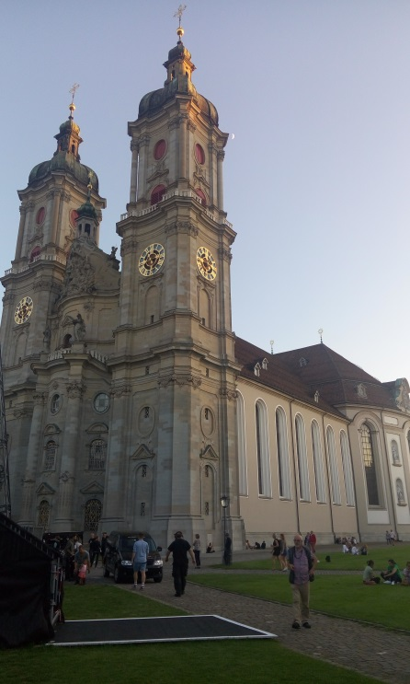
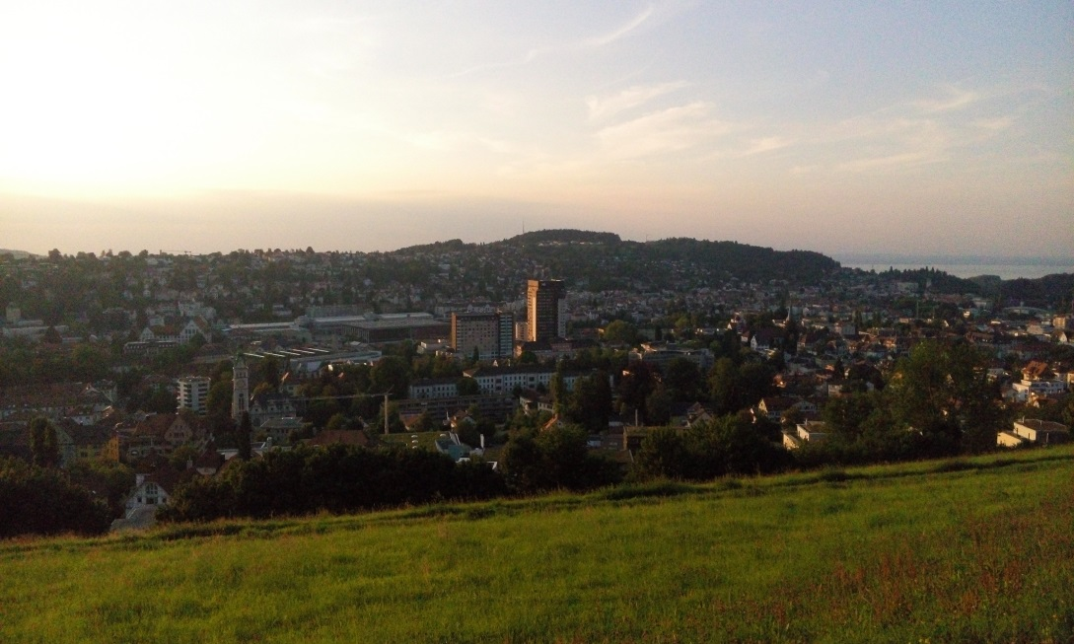
View of St Gallen from the “Drei Weiern” hill
St Gallen Cathedral
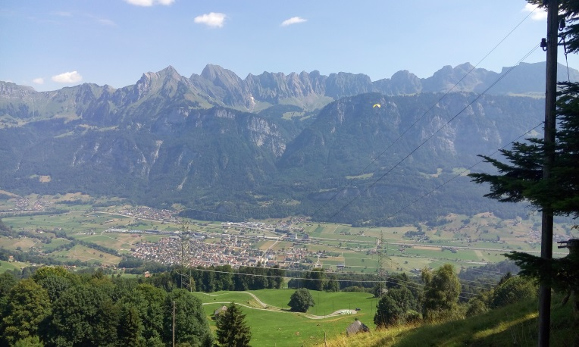
View of Flums during a client’s visit for Work
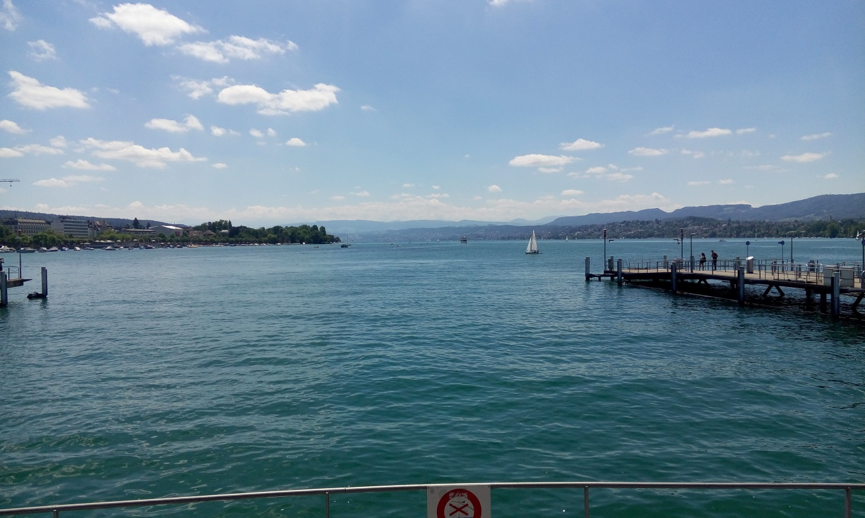
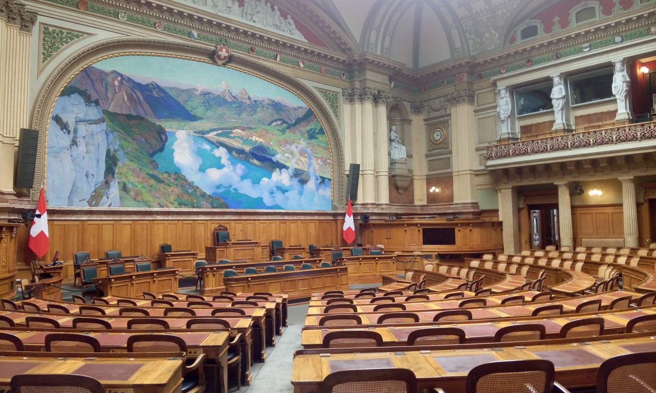
Zurich lake
Bundeshaus in Bern

